# **Format for uploading details in GitHub and Slack in word file format**

**Student Name: Shrinivasa**

**Class and Sec: VI B**

**USN: 4AL17CS092**

|  |  |  |  |  |
| --- | --- | --- | --- | --- |
| **Online Test Details** | | | | |
| **Subject** | **Python Application Programming** | | | |
| **Semester** | **VI - B** | | **Duration** | **25 Minutes** |
| **100%** | | **20/20** | | |

**Encl: snapshot of the test result**

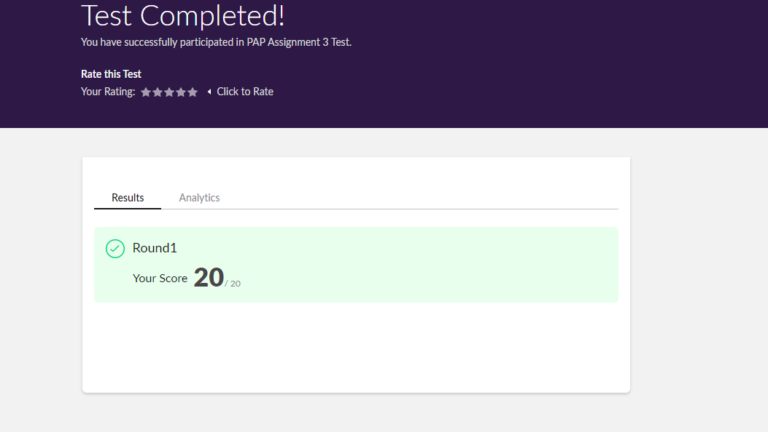

|  |  |  |  |
| --- | --- | --- | --- |
| **Certification Course Details** | | | |
| **Course** | **Introduction to Cloud** | | |
| **Certificate Provider** | **Cognitiveclass.ai** | **Duration** | **6 hours** |

**Encl: snapshots of the daily class activities (at least two snap shots)**

**Progress on 11-06-2020**



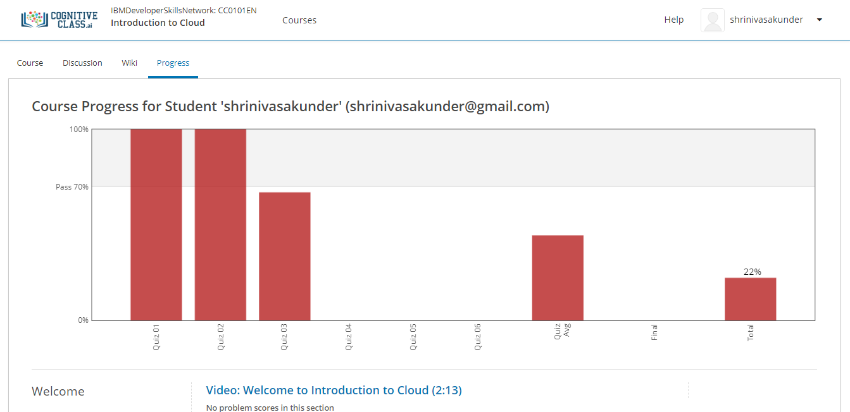

|  |  |
| --- | --- |
| **Coding Challenges** | |
| **Problem Statement: Pro1(python), Pro2(java), Pro3(python).** | |
| **Status: Completed** | |
| **Uploaded the report both in GitHub & Slack** | **Yes** |

**Encl: snapshots of your response to challenge.**

[**https://github.com/Shrinivasakunder/certification-and-online-coding/tree/master/Online%20coding**](https://github.com/Shrinivasakunder/certification-and-online-coding/tree/master/Online%20coding)

**1. Python Program to find the average of all Items in a Dictionary Step1: Get the name as key and marks as value for n students Step2: find the average of the marks of all the students and print it.**

d = dict()

n = int(input("Enter The Number Of Students: "))

for i in range(n):

name = input("Enter The Name Of Student: ")

d[name] = int(input("Enter The Marks Of Student: "))

s = 0

for i in d.values():

s = s + i

print("The Average Of The Marks Of All Students: ", s//n)

**Output:**

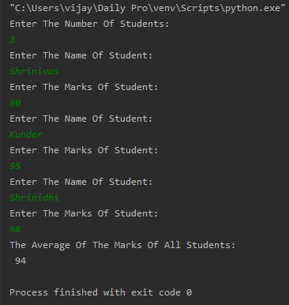

**2. Write a Java program to find the nodes which are at the maximum distance in a Binary Tree.**

**import** java.util.ArrayList;

**public** **class** MaxDistance {

**public** **static** **class** Node{

**int** data;

Node left;

Node right;

**public** Node(**int** data){

**this**.data = data;

**this**.left = **null**;

**this**.right = **null**;

}

}

**public** Node root;

**int**[] treeArray;

**int** index = 0;

**public** MaxDistance(){

root = **null**;

}

**public** **int** calculateSize(Node node)

{

**int** size = 0;

**if** (node == **null**)

**return** 0;

**else** {

size = calculateSize (node.left) + calculateSize (node.right) + 1;

**return** size;

}

}

**public** **void** convertBTtoArray(Node node) {

**if**(root == **null**){

System.***out***.println("Tree is empty");

**return**;

}

**else** {

**if**(node.left != **null**)

convertBTtoArray(node.left);

treeArray[index] = node.data;

index++;

**if**(node.right != **null**)

convertBTtoArray(node.right);

}

}

**public** **int** getDistance(Node temp, **int** n1) {

**if** (temp != **null**) {

**int** x = 0;

**if** ((temp.data == n1) || (x = getDistance(temp.left, n1)) > 0

|| (x = getDistance(temp.right, n1)) > 0) {

**return** x + 1;

}

**return** 0;

}

**return** 0;

}

**public** Node lowestCommonAncestor(Node temp, **int** node1, **int** node2) {

**if** (temp != **null**) {

**if** (temp.data == node1 || temp.data == node2) {

**return** temp;

}

Node left = lowestCommonAncestor(temp.left, node1, node2);

Node right = lowestCommonAncestor(temp.right, node1, node2);

**if** (left != **null** && right != **null**) {

**return** temp;

}

**if** (left != **null**) {

**return** left;

}

**if** (right != **null**) {

**return** right;

}

}

**return** **null**;

}

**public** **int** findDistance(**int** node1, **int** node2) {

**int** d1 = getDistance(root, node1) - 1;

**int** d2 = getDistance(root, node2) - 1;

Node ancestor = lowestCommonAncestor(root, node1, node2);

**int** d3 = getDistance(root, ancestor.data) - 1;

**return** (d1 + d2) - 2 * d3;

}

**public** **void** nodesAtMaxDistance(Node node) {

**int** maxDistance = 0, distance = 0;

ArrayList<Integer> arr = **new** ArrayList<>();

**int** treeSize = calculateSize(node);

treeArray = **new** **int**[treeSize];

convertBTtoArray(node);

**for**(**int** i = 0; i < treeArray.length; i++) {

**for**(**int** j = i; j < treeArray.length; j++) {

distance = findDistance(treeArray[i], treeArray[j]);

**if**(distance > maxDistance) {

maxDistance = distance;

arr.clear();

arr.add(treeArray[i]);

arr.add(treeArray[j]);

}

**else** **if**(distance == maxDistance) {

arr.add(treeArray[i]);

arr.add(treeArray[j]);

}

}

}

System.***out***.println("Nodes which are at maximum distance: ");

**for**(**int** i = 0; i < arr.size(); i = i + 2) {

System.***out***.println("( " + arr.get(i) + "," + arr.get(i+1) + " )");

}

}

**public** **static** **void** main(String[] args) {

MaxDistance bt = **new** MaxDistance();

bt.root = **new** Node(1);

bt.root.left = **new** Node(2);

bt.root.right = **new** Node(3);

bt.root.left.left = **new** Node(4);

bt.root.left.right = **new** Node(5);

bt.root.right.left = **new** Node(6);

bt.root.right.right = **new** Node(7);

bt.root.right.right.left = **new** Node(8);

bt.root.right.right.right = **new** Node(9);

bt.nodesAtMaxDistance(bt.root);

}

}

**Output:**

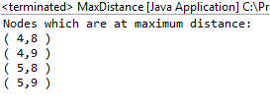

**3. Write a python function that converts a string to all uppercase, provided it contains at least 2 uppercase characters in the first 4 characters. Else print the string as it is.**

s = input("Enter The String: ")

c = 0

for i in s[:4]:

if i.isupper():

c += 1

if c > 1:

print(s.upper())

else:

print(s)

**Output:**

